U
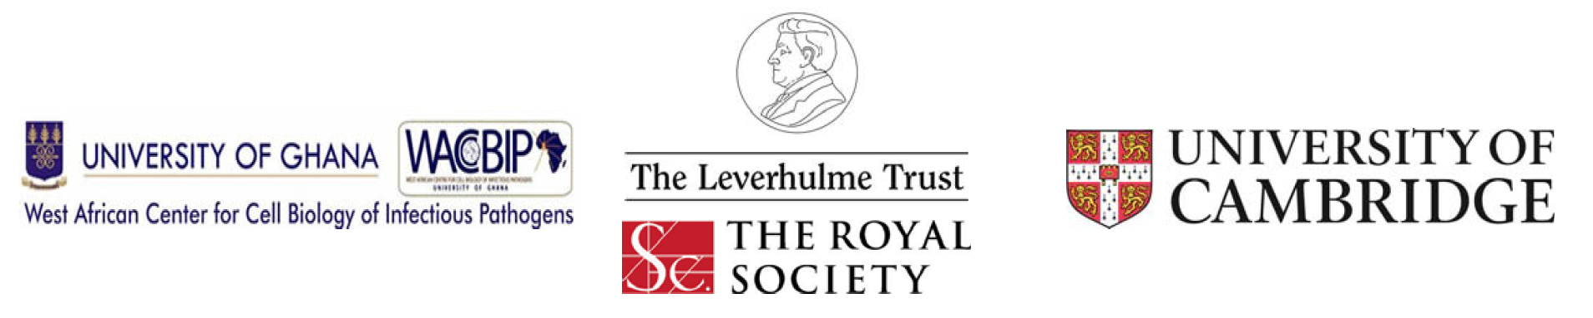

3rd Workshop on Molecular biology, pathogenesis and diagnostics of neglected diseases
July 11 - 22, 2016 at the Department of Biochemistry,
Cell and Molecular Biology,
University of Ghana, Legon, Accra

Deadline for completed applications – May 8, 2016
Please send: (1) the completed application form, (2) a CV with the names of two academic referees and (3) a statement of no more than 250 words, that describes why you wish to attend this course. Email these materials to: waccbipleader@ug.edu.gh

Name: ________________________________________________________________________

Institution: _____________________________________________________________________

Address: ______________________________________________________________________

_______________________________________________________________________

_______________________________________________________________________

Phone number: _________________________________________________________________

Fax number: ___________________________________________________________________

Email: ________________________________________________________________________

Research area: _________________________________________________________________

Name of Advisor/Supervisor: ______________________________________________________

Contact information of Advisor/Supervisor (email and Phone number): ______________________

______________________________________________________________________________

